Q1: (How to get MTU)

In the terminal use the command “netsh interface ipv4 show subinterfaces” to find the MTU

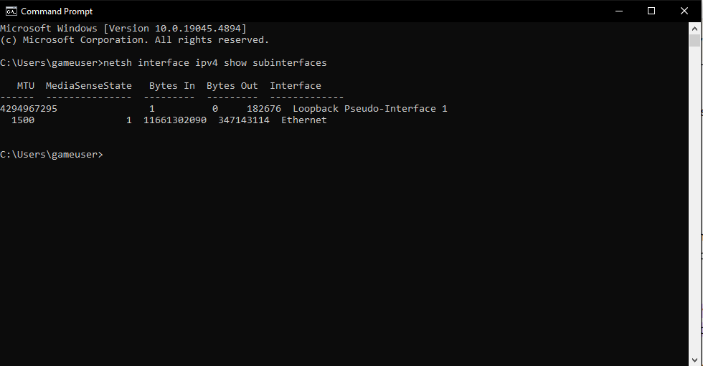

Q2: (TCP header)

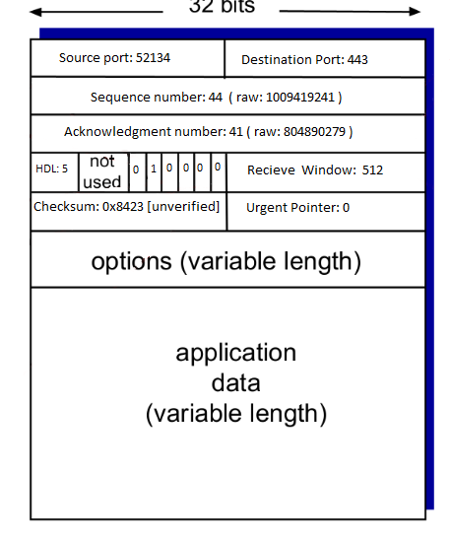

**Source Port**: specifies the port number of the sender

**Destination Port:** Identifies the application on the receiving machine intended for the data

**Sequence Number:** counter used to keep track of eery byte that is sent out by the host

**Acknowledgement Number:** indicates which byte in the stream is expected next and which bytes have been received

**Header Length:** Size of the TCP header

**Urgent Flag:** Allows us to mark segment of data as urgent

**Acknowledgement flag:** acknowledgement of bytes received by peer

**Push Flag:** used to push data to the application layer immediately

**Reset Flag:**  indicates the state and direction of TCP connection

**Syn Flah:**  used to initiate TCP connection by sending synchronization request to the remote endpoint

**Fin Flag:** Indicates the end of data transmission to finish a TCP connection

**Receive Window:**  dictates how much data a TCP receiver can accept before sending an acknowledgement back to TCP sender

**Checksum:**  used for the error detection in header to ensure data integrity during the transmission

**Urgent Pointer:** marks a segment of the data as urgent

Q3:

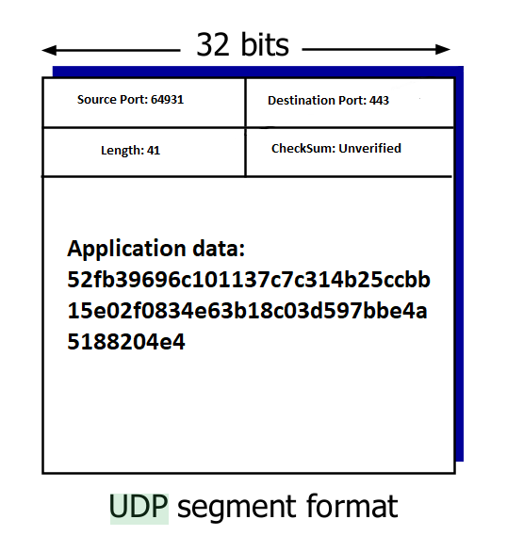

**Source Port**: specifies the port number of the sender

**Destination Port:** Identifies the application on the receiving machine intended for the data

**Length:** number of bytes for the UDP header and its data

**Checksum:**  used for the error detection in header to ensure data integrity during the transmission